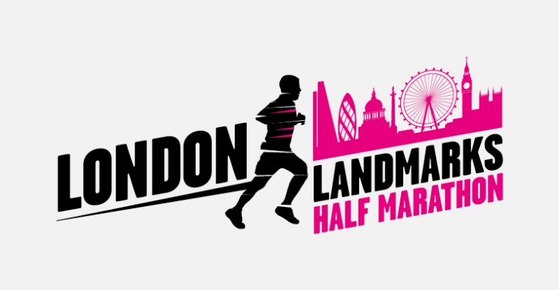

**London Landmarks Media Toolkit**

Dear Runner

Firstly, a BIG thank you for running the London Landmarks Half Marathon for your chosen charity. Whatever you raise will make a huge difference.This toolkit will get people talking about your story and hopefully donating as well.It’s quick and easy to use - simply fill in the gaps.

**Getting started**

* Fill in the template below and send to your local newspaper / radio & TV station via email by 7 March 2024
* Ring your local paper, local radio and TV stations ahead of time to get the name of the person you should be talking to – use google to find the telephone number. Tell them what your story is, include all the facts but keep it short and sweet
* Subject lines are really important so use something that will catch their eye!
* If it’s a daily paper, call between 11am and 3pm. If it’s a weekly paper which is published on, for example, a Thursday, don’t call on a Wednesday as this is their busiest times.

**Fundraising event release**

Fill in the template below, replacing the prompt text in yellow with your own details. Delete any instructions before sending out. Make sure you’re happy with what you’ve written, check spelling and the finer details. Remember to attach your photo along with the release.

**Template**

[Insert date]

LOCAL [MAN/WOMAN/PERSON] TO TACKLE HALF MARATHON [UNIQUE STORY: WEARING XXX, AS PART OF XXXX, IN WORLD RECORD BID FOR XXXX, IN AID OF [NAME CHARITY]

[name] from [town, city] is set to tackle the London Landmarks Half Marathon on Sunday 7th April, 2024 in a bid to raise vital funds for charity [Name]. [Add in a unique story, details about reasons for running: just a few sentences]

The [age] year old, who works as a [insert job title] started running in [year] [more detail about why started running if applicable] and will run 13.1 miles through central London alongside 18,000 other participants. [Further information about you and why you are taking part]

Lia Fyles, Race Director added: “The London Landmarks Half Marathon was born in 2014 and was created to bring together as many charities as possible to raise much needed funds. With our offices based in the heart of the City, we saw that a central London half marathon taking in the City and all the capital’s landmarks did not exist! The event is extra special as we celebrate London’s wonderful culture and communities, by having brilliant performers, volunteers and community groups from across the capital entertaining and supporting runners along the route. After all, it is the people that make the London Landmarks Half Marathon, the unforgettable event we all know and love.”

[NAME] said “It’s such a fantastic cause and I’m looking forward to raising as much money as possible.” [Personalise your quote with additional information]

The London Landmarks Half Marathon route showcases ‘The Grand. The Quirky. The Hidden.’ of central London. It is the only half marathon to go through both the City of London and Westminster and aims to raise £10 million for charity. It highlights the iconic landmarks of the capital such as Big Ben, St Paul’s Cathedral, Nelson’s Column, the Gherkin, the Shard, the Tower of London and the London Eye and it also unearths and promotes the hidden highlights of the city, with an emphasis on historical and cultural gems.

Along the route, activations bring these hidden highlights to life, shining a spotlight on London’s wonderful history and culture such as The creator of the Bowler Hat, Dr Johnson’s house who was the creator of the English Dictionary, Postman’s Park celebrating London’s postal history, the Bow Bells and hidden Roman Baths. There will also be music, DJs, dance acts and charity cheer stations giving runners a boost throughout the race.

For more information, images or interviews please contact [Insert your name, telephone number and email address here]

-ENDS-

**Notes to Editors:**

The London Landmarks Half Marathon is the only half marathon to go through both the City of London and the City of Westminster. The unique route takes runners past a stunning landscape of iconic landmarks as well as immersing them in London’s secret, quirky and hidden history! Organised by Tommy’s for the benefit of many good causes, the LLHM is 100% not-for-profit. For more information or route details, please visit [www.llhm.co.uk](http://www.llhm.co.uk)

Tommy’s is a national charity that works tirelessly to reduce the UK’s unacceptable rates of miscarriage, stillbirth and premature birth. Tommy’s funds pioneering medical research to discover the causes of baby loss and helps parents at every stage of their pregnancy journeys, supporting them and their partners with expert information and care. Tommy’s wants to make pregnancy safer for all and ensure that excellent maternity care is available for every family, every baby, everywhere. [www.tommys.org](http://www.tommys.org). Charity reg. no’s 1060508 and SC039280

**What next?**

* Send your press release by email. Wait a day and ring the named person to find out if they are interested in the story or if they need any further information
* The paper will want a photo of you. Ask a friend to help and do something fun, in your running kit, in good lighting and smile. Ask the journalist if they’ll use your story.
* Let us know, we’d love to see your story too! Please share your story with us **support@llhm.co.uk**